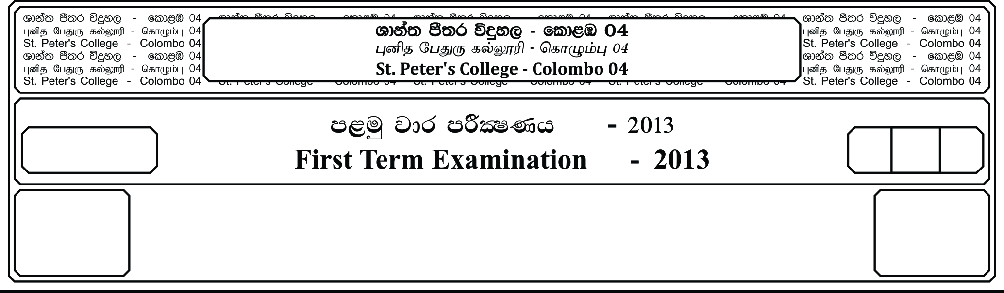

12 fY%aKsh

GRADE 12

E

meh

Hour

I

**m<uq jdr mÍCIKh - 2021**

**First Term Examination - 2021**

l%sia;shdks O¾uh - »

**CHRISTIANITY – I**

**Answer all questions.**

**Underline the correct answer.**

01. The literal meaning of the word Byblos is “__________”

i. Paper ii. Human iii. Letter

iv. Biblon v. Latin

02. __________ is the Latin translation of the Bible (from Hebrew by Jerome)

i. Vulgate ii. Vulgata iii. Biblos

iv. Biblia v. Bible

03. The original languages in which Bible was written,

i. Hebrew , Aramaic , Greek ii. Greek , English , Spanish

iii. Spanish , Greek , Aramaic iv. Greek , Spanish , Hebrew

v. English , Hebrew , Spanish

04. Catholic use __________ or LXX is the earliest extant Greek translation of the Old Testament from the original Hebrew,

i. Septuagint ii. Masoretic iii. Aramaic

iv. Greek word v. Vulgata

05. In 150 AD St. Justin Accuse Jews for cutting down word of God in “__________”.

i. Conversation with Jesus ii. Conversation with Hebrew

iii. Conversation with Romans iv. Conversation with Galilee

v. Conversation with God

06. Greek word for revelation is __________

i. Apocalypse ii. Vulgate iii. Bible

iv. Psalms v. Jude

07. According to Providentissimus Deus (November 18, 1893 of Leo xiii) Holy Scripture has __________

i. 3 Authors ii. 2 Authors iii. 5 Authors

iv. 10 Authors v. 1 Author

08. The areas that begins from the Persian Bay and margined towards the Mediterranean coast through Iraq and extended towards the Western Nile River is known as the “__________”

i. Fertile crescent ii. Canaan iii. Promise land

iv. Holy land v. Palestine

09. The Geographical disparity and four natural areas,

i. Coastal areas , Western Mountains , Jordan Valley and Eastern Mountains

ii. Promise land , Coastal areas , Southern East

iii. Southern , East , West , Promise land

iv. Coastal arias , Jordan Valley , Egypt

v. Eastern Mountains , Jordan Valley , Promise Land

10. Coastal areas are consists of 3 valleys.

i. Akko Valley , Sharon Valley , Philistia Valley.

ii. Philistia , Ethiopia Valley , Mount Jordan.

iii. Mount Jordan , Philistia Valley

iv. Akko Valley , Philistia , Ethiopia

v. Akko Valley , Tabour Valley

11. Negeb means __________ is the context of the Holy Bible,

i. Dry ii. Wet iii. Sarc iv. Alive v. Soft

12. King __________ was the last king of David’s Generation.

i. Zedekiah ii. Josiah iii. Jehoiakim

iv. Jehoiachin v. Samuel

13. In __________ king Cyrus conquered and brought Babylon under his authority,

i. 539 BC ii. 555 BC iii. 541 BC

iv. 511 BC v. 538 BC

14. The Hebrew term __________ is used to address the Pentateuch,

i. Torah ii. Leviticas iii. Numbers

iv. Genesis v. Song of Song

15. __________ is the first 5 books of the Holy Bible.

i. Pentateuch ii. Law of books iii. Numbers

iv. Genesis v. Sirach

16. Sin leads man to suffering __________ __________

i. Love , Life ii. Pain and death iii. Life and death

iv. Death and heavens v. Love of God

17. In Elohistic tradition __________ refers to God.

i. Yahweh ii. Elohist iii. Deuteronomisyt

iv. Priestly v. Moses

18. The encyclical on “Divine Providence” was written by,

i. Pope John the 23rd ii. Pope Leo the 13th

iii. Pope Pius the 12th iv. Pope Pius the 10th

v. Pope Pius the 11th

19. Community of Jews in the __________ didn’t know Hebrew,

i. Diaspora ii. Egypt iii. Lebanon

iv. Israel v. Babylon

20. __________ means text of the common people,

i. Vulgate ii. Vulgata iii. Masoretic

iv. Biblos v. Israel

**Part – II**

**Answer all given questions.**

01. Name the major prophets in the Holy Bible.

02. Name 05 miracles performed by Jesus.

03. Write 05 qualities of a Christian Leader.

04. Explain in 05 points the way you act in the society as youth following the exemplary life of Jesus.

05. Name 12 judges in the book of Judges.

06. Name the 1st book in the Holy Bible.

07. Write the names of the 12 Apostles.

08. Write the name of the river which flows between Jerusalem and Mount Olive.

09. Name the highest city in Palestine.

10. What was the purpose of making Bethel and Dan a place of worship.